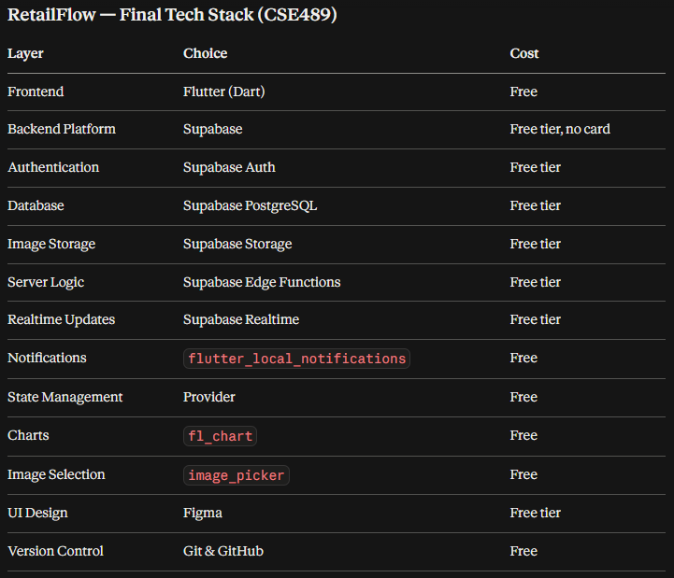

erDiagram
USER {
string userId PK
string name
string email UK
string passwordHash
string role
string branchId FK
string currentBadgeId FK
int totalLifetimePoints
boolean isActive
datetime createdAt
}

BRANCH {
string branchId PK
string name
string location
string managerId FK
boolean isActive
datetime createdAt
}

PRODUCT {
string productId PK
string name
string category
decimal unitPrice
boolean isActive
datetime createdAt
}

SHIFT {
string shiftId PK
string name
time startTime
time endTime
boolean isActive
}

SHIFT_ASSIGNMENT {
string shiftAssignmentId PK
string userId FK
string branchId FK
string shiftId FK
date workDate
string status
datetime assignedAt
}

TASK {
string taskId PK
string title
string description
string frequency
string branchId FK
string createdBy FK
int basePoints
int photoBonusPoints
boolean photoRequired
boolean isActive
datetime createdAt
}

TASK_ASSIGNMENT {
string assignmentId PK
string taskId FK
string userId FK
date scheduledDate
datetime dueAt
string status
datetime assignedAt
}

TASK_COMPLETION {
string completionId PK
string assignmentId FK
string submittedBy FK
string photoUrl
string status
int attemptNumber
datetime submittedAt
string reviewedBy FK
datetime reviewedAt
string rejectionReason
}

SALES_TARGET {
string targetId PK
string branchId FK
string shiftId FK
date targetDate
decimal targetAmount
string createdBy FK
datetime createdAt
}

SALES_ENTRY {
string saleId PK
string branchId FK
string shiftId FK
string productId FK
string recordedBy FK
int quantity
decimal unitPrice
decimal totalAmount
date saleDate
datetime createdAt
}

COMPETITION {
string competitionId PK
string title
string description
date startDate
date endDate
string status
string createdBy FK
datetime createdAt
}

COMPETITION_BRANCH {
string competitionBranchId PK
string competitionId FK
string branchId FK
}

COMPETITION_PRODUCT {
string competitionProductId PK
string competitionId FK
string productId FK
int pointsPerUnit
}

BRANCH_LEADERBOARD_ENTRY {
string leaderboardEntryId PK
string competitionId FK
string branchId FK
int totalUnits
decimal totalSales
int competitionPoints
int rank
int previousRank
datetime updatedAt
}

POINTS_TRANSACTION {
string transactionId PK
string userId FK
string taskCompletionId FK
string type
int points
string description
datetime transactionDate
}

BADGE {
string badgeId PK
string name
int minimumPoints
int maximumPoints
string description
}

BRANCH_REWARD {
string rewardId PK
string competitionId FK
string branchId FK
int achievedRank
string title
string description
datetime awardedAt
}

NOTIFICATION {
string notificationId PK
string userId FK
string title
string message
string type
boolean isRead
datetime createdAt
}

BRANCH ||--o{ USER : employs
USER o|--o{ BRANCH : manages
USER ||--o{ SHIFT_ASSIGNMENT : receives
BRANCH ||--o{ SHIFT_ASSIGNMENT : schedules
SHIFT ||--o{ SHIFT_ASSIGNMENT : defines
BRANCH ||--o{ TASK : contains
USER ||--o{ TASK : creates
TASK ||--o{ TASK_ASSIGNMENT : generates
USER ||--o{ TASK_ASSIGNMENT : receives
TASK_ASSIGNMENT ||--o{ TASK_COMPLETION : produces
USER ||--o{ TASK_COMPLETION : submits
USER ||--o{ TASK_COMPLETION : reviews
BRANCH ||--o{ SALES_TARGET : has
SHIFT ||--o{ SALES_TARGET : applies_to
USER ||--o{ SALES_TARGET : creates
BRANCH ||--o{ SALES_ENTRY : records_sales
SHIFT ||--o{ SALES_ENTRY : occurs_in
PRODUCT ||--o{ SALES_ENTRY : contains
USER ||--o{ SALES_ENTRY : recorded_by
USER ||--o{ COMPETITION : creates
COMPETITION ||--o{ COMPETITION_BRANCH : includes
BRANCH ||--o{ COMPETITION_BRANCH : participates_in
COMPETITION ||--o{ COMPETITION_PRODUCT : includes
PRODUCT ||--o{ COMPETITION_PRODUCT : qualifies_for
COMPETITION ||--o{ BRANCH_LEADERBOARD_ENTRY : has
BRANCH ||--o{ BRANCH_LEADERBOARD_ENTRY : ranked_in
USER ||--o{ POINTS_TRANSACTION : earns
TASK_COMPLETION o|--o{ POINTS_TRANSACTION : generates
BADGE ||--o{ USER : assigned_to
COMPETITION ||--o{ BRANCH_REWARD : provides
BRANCH ||--o{ BRANCH_REWARD : receives
USER ||--o{ NOTIFICATION : receives

